Brief Summary On SDLC

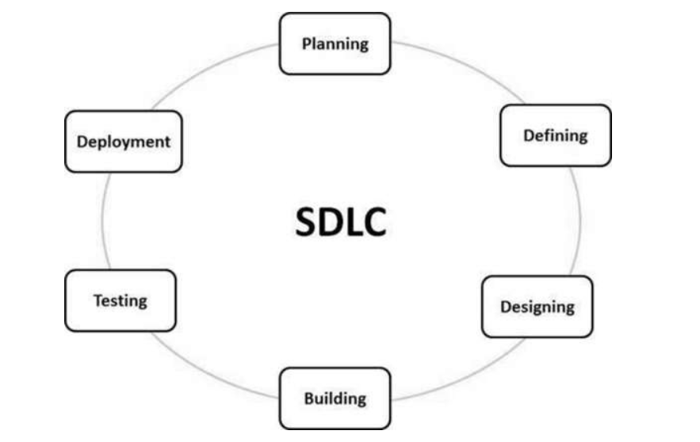

SDLC is a process followed for a software project, within a software organization. It consists of a detailed plan describing how to develop, maintain, replace and alter or enhance specific software.

1. **Planning and Requirement Analysis:** Senior team members gather inputs from customers, sales, and market research to define project scope and feasibility in terms of cost, operations, and technology.
2. **Defining Requirements:** Product requirements are documented in an SRS (Software Requirement Specification) and approved by stakeholders.
3. **Designing the Product Architecture:** Architects create multiple design approaches based on the SRS. The best one is selected using a DDS (Design Document Specification), considering risks, modularity, time, and cost.
4. **Building the Product:** Developers start coding based on the DDS using appropriate tools and guidelines.
5. **Testing the Product:** The product is thoroughly tested for bugs and issues, which are fixed and retested until quality standards are met.
6. **Deployment and Maintenance:** The final product is released to the market, sometimes in phases. Ongoing maintenance and updates are provided post-deployment.